

PROJECT

**“Building Secure Network at Hospital”**

**Name :**

**Muhammad Farhan Hanif**

**Muhammad Fadil Ardiansyah**

**Muhammad Andre Juliansyah**

**Reg. Number :**

**1710010124**

**1710010123**

**1710010119**

PREFACE

First of all, thanks to Allah SWT because of the help of Allah, authors finished writing the paper entitled “Building Secure Network at Hospital” right in the calculated time.

The purpose in writing this paper is to fulfill the assignment that given by Mrs. Indah Ayu Yuliani as lecturer in CEP-CCIT FTUI.

In arranging this paper, the writer truly get lots challenges and obstructions but with help of many individuals who can’t be mentioned one by one, those obstructions could have passed. writer also realized there are still many mistakes in process of writing this paper.

Because of that, the writer says thank to all individuals who helps in the process of writing this paper. hopefully Allah replies all helps and bless all. The writer realized that this paper is still not perfect in arrangement and the content. Then the writer hopes the criticism from the readers can help the writer in perfecting the next paper. Last but not the least Hopefully, this paper can help the readers to gain more knowledge about Building Secure Network.

Depok, 30 September 2017

Authors

TABLE OF CONTENTS

PREFACE i

TABLE OF CONTENTS i

TABLE OF FIGURES i

TABLE OF TABLES i

CHAPTER I. INTRODUCTION 1

I.1 Background 1

I.2 Writing Objective 1

I.3 Problem Domain 1

1.4 Writing Methodology 1

I.5 Writing Framework 1

CHAPTER II. BASIC THEORY 1

II.1 Hardware Definition 1

II.2 Software Definition 1

II.3 Introduction to Networks 1

II.4 Network Architectures 1

II.5 Network Topology 1

II.6 Identifying Computer on a Network 1

II.7 Network Media 1

II.8 Network Device 1

II.9 Network Operating System 1

CHAPTER III. PROBLEM ANALYSIS 1

III.1 Network Analysis 1

III.2 Network Architecture 1

III.3 Network Topology 1

III.4 Network Device 1

III.5 Software 1

III.6 Network Media 1

III.7 Cost 1

CHAPTER IV. CONCLUSION AND SUGGESTION 1

IV.1 Conclusion 1

IV.2 Suggestion 1

BIBLIOGRAPHY 1

Reference From Site : 1

TABLE OF FIGURES

Figure 2.1 Example of a Network 1

Figure 2.2 Client Server Model 1

Figure 2.3 Peer to Peer Network 1

Figure 2.4 Network Topology 1

Figure 2.5 Router 1

Figure 2.6 Switch 1

Figure 2.7 Server Computer 1

Figure 2.8 Access Points 1

Figure 2.9 IP Phone 1

Figure 3.1 The Hospital’s Network Scheme 1

Figure 3.2 Mikrotik RB951G-2HnD 1

Figure 3.3 Belden UTP Cable 1

Figure 3.4 Cisco SG-200-08 Switch 1

Figure 3.5 Cisco SG-200-18 Switch 1

Figure 3.6 YeaLink IPPhone 1

Figure 3.7 Dell Poweredge Server 1

Figure 3.8 Ubiquiti Access Point 1

Figure 3.9 HP AIO PC 1

Figure 3.10 Epson Stylus LAN Printer 1

TABLE OF TABLES

Tables 3.1 Device Mapping 1

Tables 3.2 IP Mapping 1

Tables 3.3 Network Costs 1

CHAPTER I. INTRODUCTION

I.1 Background

A network is a collection of computers, servers, mainframes, network devices, peripherals, or other devices connected to one another to allow the sharing of data.

In this project, we asked to design a network. Therefore we choose to design a Hospital’s Network System. In this document our group will explain how to create such network.

I.2 Writing Objective

This Project will be discussing about:

1. Hardware Definition
2. Software Definition
3. Introduction to Networks
4. Network Architecture
5. Network Topology
6. Identifying Computer on a network
7. Network Media
8. Network Device
9. Network Operating System
10. Network Cost

I.3 Problem Domain

To keep this Project Topic Focused, this Document will be limited on these following subjects:

1. To Explain about Hardware Definition
2. To Explain about Software Definition
3. To Explain about what is a Network
4. To Explain about Network Architecture
5. To Explain about Network Topology
6. To Explain about method to Identify a Computer on the Network
7. To Explain about Network Media
8. To Explain about Network Device
9. To Explain about Network Operating System
10. To Calculate how much does the Network system cost

1.4 Writing Methodology

The method used is the method of research with data collection techniques using observations from reliable media and source.

I.5 Writing Framework

To know the description of this paper, the authors divides it into four chapters. Each chapter in this study are interconnected between chapters with chapter one another by systematic writing as follows:

**CHAPTER I INTRODUCTION**

Tell about the background, writing objective, problem domain, writing methodology and writing framework

**CHAPTER II BASIC OF THEORY**

Tell the definition of Operating Systems, Function of Operating System

**CHAPTER III PROBLEM ANALYSIS**

Analyzing and solve the problem that contained in problem domain

**CHAPTER IV CONCLUSION AND SUGGESTION**

Conclude and suggest things related to ISAS

CHAPTER II. BASIC THEORY

II.1 Hardware Definition

Hardware is any physical component of a computer system that contains a circuit board, ICs, or other electronics. Whether it be a computer monitor, tablet or smartphone; it's hardware.

Without any hardware, computer would not exist, and software could not be used. Example of hardwares are : Keyboard, Mouse, Motherboard, etc.

There are 4 types of hardware;

1. Input Devices are used to insert or supply data to the computer, the examples of Input Devices are Keyboard, Mouse, Joystick, etc.
2. Process Devices are used to process data using program instructor, examples of Process Device are Processor, GPU, etc.
3. Output Devices are used to display data and programs from the computer, examples of Output devices are Monitor, and Printer.
4. Storage Devices are used to store programs and data, examples of storage devices are Harddisk, and flashdisk (USB Drive).

II.2 Software Definition

Software is a collection of instructions that enable the user to interact with a computer, its hardware, or perform tasks. Without software, most computers would be useless. For example, without Internet browser software, user could not surf the Internet or read this page and without an operating system, the browser could not run on your computer.

Computer software can be put into categories based on common function, type, or field of use. There are three broad classifications:

1. ***Application software*** is the general designation of computer programs for performing tasks. Application software may be general purpose (e.g word processing).
2. ***System software*** is a generic term referring to the computer programs used to start and run computer systems including diverse application software and networks, or can be described as Operating System.
3. ***Utility Software*** is a specific software designed to achieve one purpose only.

II.3 Introduction to Networks

A network is a collection of computers, servers, mainframes, network devices, peripherals, or other devices connected to one another to allow the sharing of data. An excellent example of a network is the Internet, which connects millions of people all over the world. Below is an example image of a Office Network with multiple computers, a printer and other network devices all connected to each other and the Internet.

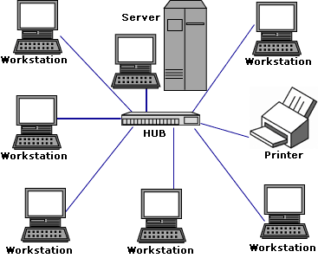

Figure 2.1 Example of a Network

II.4 Network Architectures

Network architecture, is the logical and structural layout of the network consisting of transmission equipment, software and communication protocols and infrastructure (wired or wireless) transmission of data and connectivity between components. Network Architectures in general can be described into three categories :

1. **Client-Server**

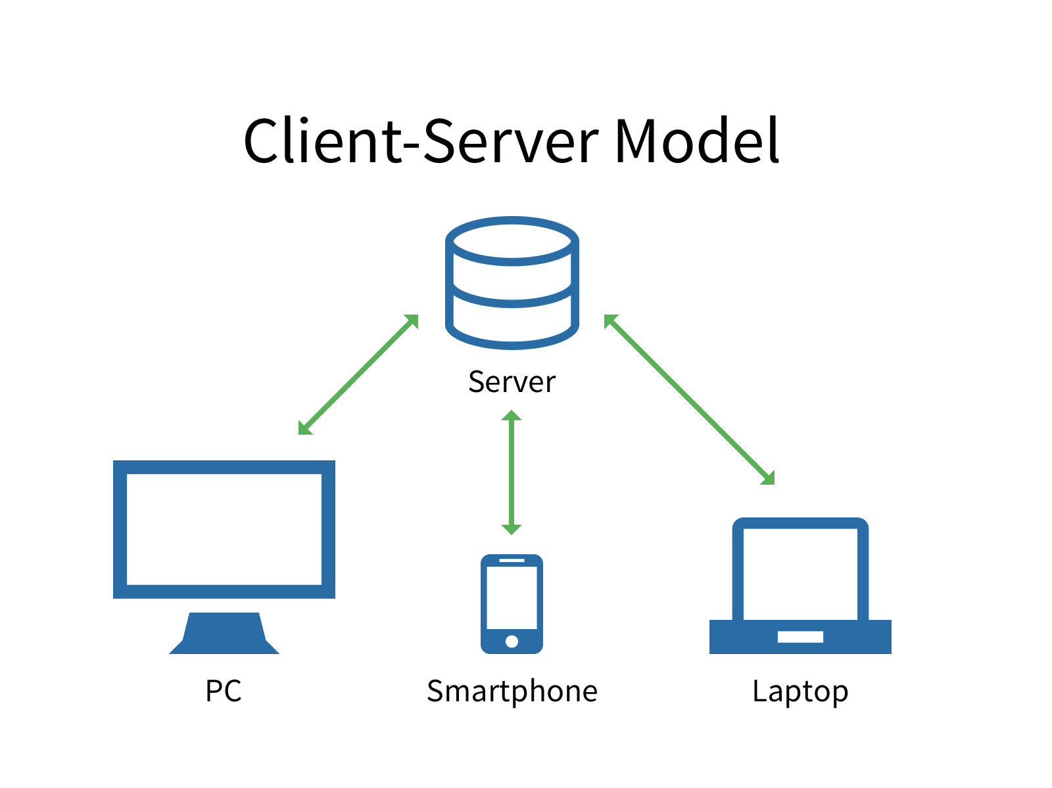

Figure 2.2 Client Server Model

The client-server model describes how a [server](https://techterms.com/definition/server) provides resources and services to one or more [clients](https://techterms.com/definition/client). Examples of servers include [web servers](https://techterms.com/definition/web_server), [mail servers](https://techterms.com/definition/mail_server), and [file servers](https://techterms.com/definition/file_server). Each of these servers provide resources to client devices, such as [desktop computers](https://techterms.com/definition/desktop_computer), [laptops](https://techterms.com/definition/laptop), [tablets](https://techterms.com/definition/tablet), and [smartphones](https://techterms.com/definition/smartphone). Most servers have a one-to-many relationship with clients, meaning a single server can provide resources to multiple clients at one time.

1. **Peer to Peer (P2P)**

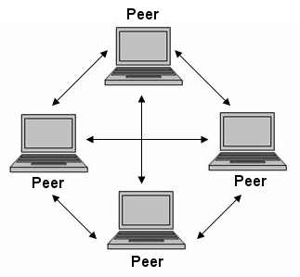

Figure 2.3 Peer to Peer Network

In a P2P network, the "peers" are computer systems which are connected to each other via the Internet. Files can be shared directly between systems on the network without the need of a central server. In other words, each computer on a P2P network becomes a file [server](https://techterms.com/definition/server) as well as a client

1. **Hybrid**

Hybrid is a combination of peer to peer and client-server network architecture.

II.5 Network Topology

A network topology is the arrangement of a network, including its nodes and connecting lines. There are two ways of defining network geometry: the physical topology and the logical (or signal) topology.

The physical topology of a network is the actual geometric layout of workstations. There are several common physical topologies, as described below and as shown in the illustrations

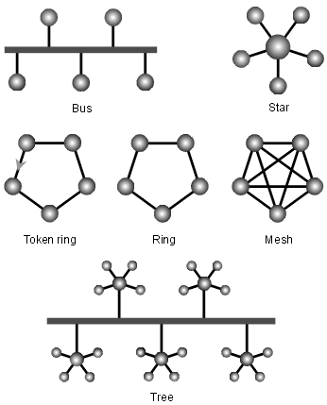

Figure 2.4 Network Topology

In the bus network topology, every workstation is connected to a main cable called the bus. Therefore, in effect, each workstation is directly connected to every other workstation in the network.

In the star network topology, there is a central computer or server to which all the workstations are directly connected. Every workstation is indirectly connected to every other through the central computer.

In the ring network topology, the workstations are connected in a closed loop configuration. Adjacent pairs of workstations are directly connected. Other pairs of workstations are indirectly connected, the data passing through one or more intermediate nodes.

If a Token Ring protocol is used in a star or ring topology, the signal travels in only one direction, carried by a so-called token from node to node.

The mesh network topology employs either of two schemes, called full mesh and partial mesh. In the full mesh topology, each workstation is connected directly to each of the others. In the partial mesh topology, some workstations are connected to all the others, and some are connected only to those other nodes with which they exchange the most data.

The tree network topology uses two or more star networks connected together. The central computers of the star networks are connected to a main bus. Thus, a tree network is a bus network of star networks.

II.6 Identifying Computer on a Network

Any computers on a network can be identified by this two following method.

1. **IP Address**

An Internet Protocol address (IP address) is a numerical label assigned to each device connected to a computer network that uses the Internet Protocol for communication. An IP address serves two principal functions: host or network interface identification and location addressing.

1. **MAC Addeess**

In a local area network (LAN) or other network, the MAC (Media Access Control) address is a computer's unique hardware number. (On an Ethernet LAN, it's the same as the computer’s Ethernet address.) When the user is connected to the Internet from the user’s computer (or host as the Internet protocol thinks of it), a correspondence table relates it’s IP address to the computer's physical (MAC) address on the LAN.

II.7 Network Media

Network media is how the network will be delivered into, network media can be divided into two type, Wired and Wireless :

1. **Wired**

A wired network is a common type of wired configuration. Most wired networks use Ethernet cables to transfer data between connected PCs. In a small wired network, a single router may be used to connect all the computers. Larger networks often involve multiple routers or switches that connect to each other.

1. **Wireless**

A **wireless network** is a computer network that uses wireless data connections between network nodes. Wireless networking is a method by which homes, telecommunications networks and business installations avoid the costly process of introducing cables into a building, or as a connection between various equipment locations. Wireless telecommunications networks are generally implemented and administered using radio communication.

II.8 Network Device

Network devices are components used to connect computers or other electronic devices together so that they can share files or resources like printers or fax machines. Devices used to setup a Local Area Network (LAN) are the most common type of network devicesused by the public. There are a lot of network devices but the writer will only focus to devices that are used by the Hospital’s Network.

1. **Router**

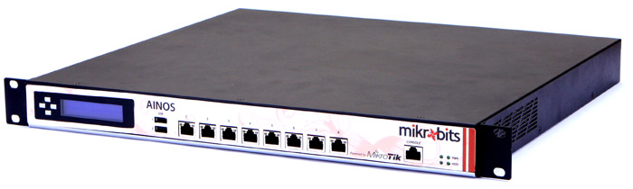

Figure 2.5 Router

A router is a network device which is responsible for routing traffic from one to another network. These two networks could be a private company network to a public network.

1. **Switch**

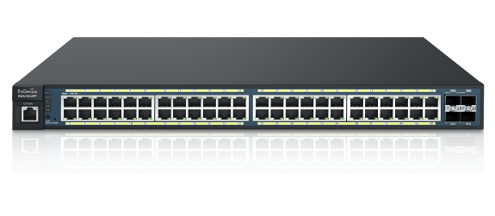

Figure 2.6 Switch

Switch works at the layer of LAN (Local Area Network). a switch does ‘filter and forwarding’ which is a more intelligent way of dealing with the data packets. A Good Switch able to perform VLAN configuration, VLAN is a group of devices on one or more LANs that are configured to communicate as if they were attached to the same wire.

1. **Server**

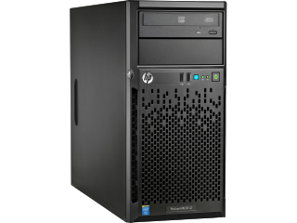

Figure 2.7 Server Computer

A server is a computer designed to process requests and deliver data to other (client) computers over a local network or the internet. Although any computer running special software can function as a server, the most typical use of the word references the very large, high-powered machines that function as the pumps pushing and pulling data across the internet.

1. **Access Point**

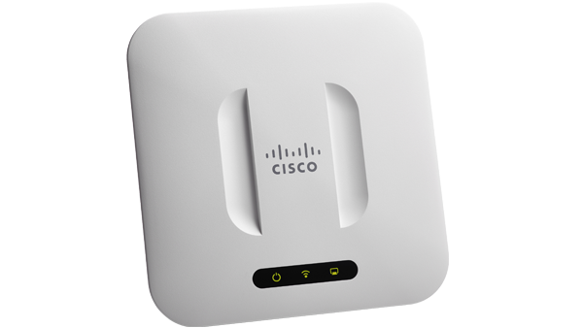

Figure 2.8 Access Points

An [access point](https://www.linksys.com/us/r/resource-center/c/business-wireless-access-points) is a device that creates a wireless local area network, or WLAN, usually in an office or large building. An access point connects to a wired router, switch, or hub via an Ethernet cable, and projects a Wi-Fi signal to a designated area. For example, if you want to enable Wi-Fi access in your company's reception area but don’t have a router within range, you can install an access point near the front desk and run an Ethernet cable through the ceiling back to the server room.

1. **IP Phone**

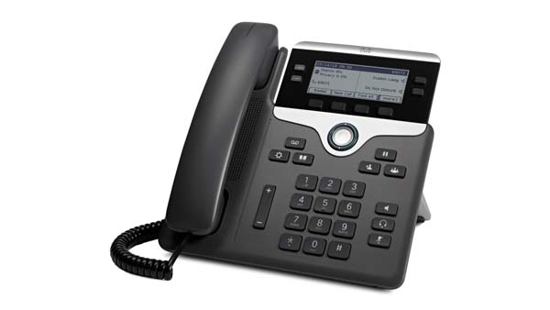

Figure 2.9 IP Phone

The term "IP phone" refers to a telephone, which enables the processing of voice communication via the internet protocol and the internet or an intranet. One often speaks of so-called Voice-over-IP telephony (VoIP telephony) or VoIP telephones. The IP telephone converts analogue voice signals into digital signals and packages these in data packages that can be transferred via Internet Protocol.

II.9 Network Operating System

A network operating system (NOS) is a computer [operating system](http://searchcio-midmarket.techtarget.com/definition/operating-system) system that is designed primarily to support [workstation](http://searchmobilecomputing.techtarget.com/definition/workstation), [personal computer](http://whatis.techtarget.com/definition/personal-computer-PC), and, in some instances, older [terminal](http://searchnetworking.techtarget.com/definition/terminal) that are connected on a local area network (LAN). Artisoft's LANtastic, Banyan VINES, Novell's NetWare, and Microsoft's LAN Manager are examples of network operating systems. In addition, some multi-purpose operating systems, such as [Windows NT](http://searchwinit.techtarget.com/definition/Windows-NT) and Digital's [OpenVMS](http://whatis.techtarget.com/definition/OpenVMS) come with capabilities that enable them to be described as a network operating system.

CHAPTER III. PROBLEM ANALYSIS

III.1 Network Analysis

This Project is consists of Building a Network System at Hospital for creating ease access between each Employees or even Visitor. The Network Blueprints of the Hospital contains 1 Pharmacy Room, 1 Waiting Room, 1 Radiology Room, 1 Laboratorium, Receptionist, Administration, And the Server Room. The Hospital Manager wants to create a Single Floor network that each employees can communicate via network, so the employees did not have to get out from their room also The Manager wants to have their own Server so the Employees can store Hospital Archives in the Local Server and accessible from the internet.

Below is the Blueprint of the Project :

1. **Device Mapping**

|  |  |
| --- | --- |
| Pharmacy Room | * 1 VoIP Phone * 2 PC * 1 Switch |
| Waiting Room | * 1 Access Point |
| Radiology | * 2 PC * 1 VoIP Phone * 1 Switch * 1 Printer |
| Laboratorium | * 10 PC * 1 VoIP Phone * 1 Switch |
| Receptionist | * 2 PC * 1 VoIP Phone * 1 Switch * 1 Printer |
| Administration | * 1 VoIP Phone * 3 PC * 1 Switch * 1 Printer |
| Server Room | * 1 PC * 1 Server * 1 Router * 1 Switch |
| Hall | * 1 Wallmounted Network Rack * 1 Switches * 1 Router |

Tables 3.1 Device Mapping

|  |  |
| --- | --- |
| Pharmacy Room | 192.168.14.0/24 (Vlan 14) |
| Waiting Room | 172.16.0.0/22 |
| Radiology | 192.168.12.0/24 (Vlan 12) |
| Laboratorium | 192.168.11.0/24 (Vlan 11) |
| Receptionist | 192.168.13.0/24 (Vlan 13) |
| Administration | 192.168.10.0/24 (Vlan 10) |
| Server Room | 192.168.100.0/24 |
| Link from Router 1 to Router 2 | 192.168.200.0/30 |
| Internet | From ISP |
| IP Phone | 192.168.210.0/24 (Vlan 20) |

1. **IP Allocation**

Tables 3.2 IP Mapping

1. **Network Scheme**

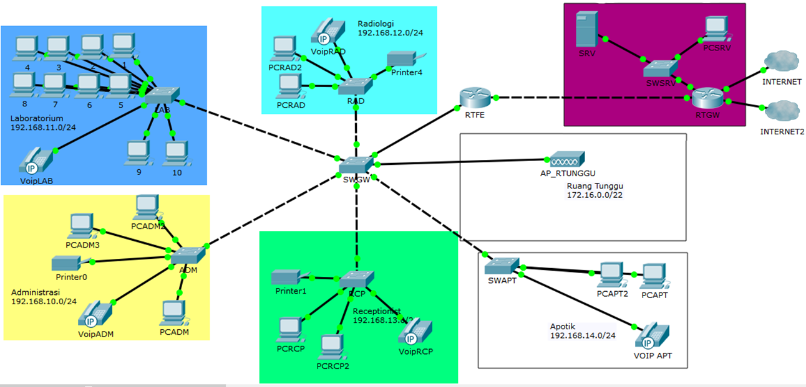

Figure 3.1 The Hospital’s Network Scheme

1. **System Concept**

This system is mainly based on 2 Router and 1 Main switch, the First router work as the Internet Gateway and bridge the Server network to the Hospital network, the Second router work mainly as parent VLAN interface and also provide another service such as DHCP, Firewall, LAN Gateway, etc.

The main switch that placed on the Lobby is work as VLAN Gateway, it functions are to distribute VLAN ID to every switches at hospital.

Waiting Room is assigned with Class B IP 172.16.0.0/22, The reason of using this Class B class is to Anticipate the lacking of Reserved IP for users to access the Access-Point, and the Waiting room is also using a Hotspot and QoS to manage Bandwith and Internet usage for every Users that are connected to the Access Point.

Things to note is the Main server are applied Load Balancing Method, it means the way of Server network connect to the internet is use the separate ISP from the other, to ensure availability and integrity.

III.2 Network Architecture

In this Project, the architecture that will be used in the Network is Client-Server Architecture, Client/server is a program relationship in which one program (the client) requests a service or resource from another program (the server).

Although the client/server model can be used by programs within a single computer, it is a more important concept for networking.  In this case, the client establishes a connection to the server over a local area network (LAN) or wide-area network (WAN), such as the Doctor requesting a medical report from the Hospital’s Databases, the Patient using the Internet, etc. Once the server has fulfilled the client's request, the connection is terminated.

III.3 Network Topology

Because of there is lot of room in the Hospital, the Network requires a combination of more than one Topology. Based on that fact, the Network will use Hybrid as the Topology of the Network.

Hybrid, as the name suggests, is mixture of two different things. Similarly in this type of topology that integrate two or more different topologies to form a resultant topology which has good points (as well as weaknesses) of all the constituent basic topologies rather than having characteristics of one specific topology. This combination of topologies is done according to the requirements of the organization.

Ofcourse this kind of topology have benefit and drawbacks:

1. **Benefit**
   * **Reliable**, Hospital means a failure will costs someone’s life, a reliable network is needed. fault detection and troubleshooting is easy in this type of topology. The part in which fault is detected can be isolated from the rest of network and required corrective measures can be taken, Without affecting the functioning of rest of the network.
   * **Scalable**, If the Hospital needs an additional Networks for its new instalation (Dept.), the network can be easily expanded by adding new components, without disturbing existing architecture.
   * **Flexible**, Hybrid Network can be designed according to the requirements of the Hospital and by optimizing the available resources. Special care can be given to area where traffic is high as well as where chances of fault are high.
2. **Drawbacks**

* **Complexity of Design**, One of the biggest drawback of hybrid topology is its design. Its not easy to design this type of architecture and its a tough job for designers. Configuration and installation process needs to be very efficient.
* **Costly Hub/switches**, The hubs used to connect two distinct networks, are very expensive. These hubs are different from usual hubs as they need to be intelligent enough to work with different architectures and should be function even if a part of network is down.
* **Costly Infrastructure**, As hybrid architectures are usually larger in scale, they require a lot of cables, cooling systems, sophisticate network devices, etc.

III.4 Network Device

There are lot of network devices with various functionality, however, the Hospital’s Network needs these Devices :

1. 2x Mikrotik Routerboard RB951G-2HnD Router

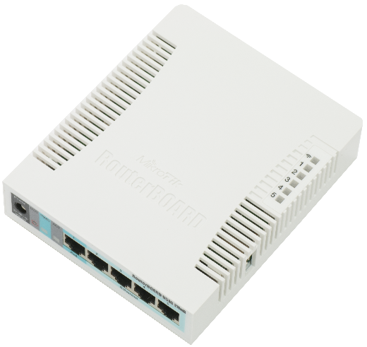

Figure 3.2 Mikrotik RB951G-2HnD

The RB951G-2HnD is a wireless Gigabit Routerboard swith a new generation Atheros CPU and more processing power. It has five Ethernet ports, one USB 2.0 port and a high power 2.4GHz 1000mW 802.11b/g/n wireless AP with antennas built in.

In comparison with previous model RB751G-2HnD, it has more powerful 600Mhz CPU (instead of 400Mhz), more RAM - 128MB instead of 64MB, same form factor and price. The device is very small and will look good in any home or office, wall mounting anchor holes are provided.

1. 5x Roll Belden CAT5E 300 Metres UTP Cable



Figure 3.3 Belden UTP Cable

Belden Cable has a good reputation among network engineers, it have good signal strength, improved signal-to-noise performance and, larger copper.

1. 6x Cisco SG-200-08 & 1x Cisco SG-200-18 Manageable Switch

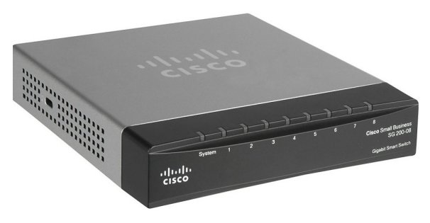

Figure 3.4 Cisco SG-200-08 Switch

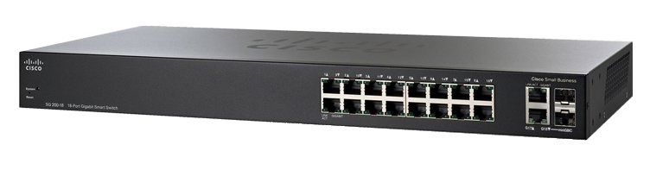

Figure 3.5 Cisco SG-200-18 Switch

Cisco 200 Series switches offer essential Layer 2 switch features at a much lower price than advanced managed switches, Cisco 200 Simplify the deployment of voice, wireless, and video surveillance systems with automated QoS (Quality of Services) and voice VLAN features, and optional Power over Ethernet (PoE) connectivity, perfect for the Hospital’s network which requires strong Phone Line over IP.

1. 5x VoIP Yealink SIP T21P E2 IP Phone

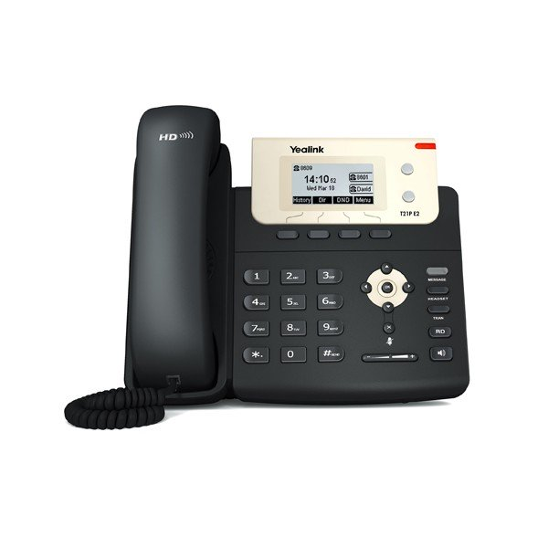

Figure 3.6 YeaLink IPPhone

The **Yealink T21P E2** is a 2-line entry level IP phone that can perform the basic functions you need for extended phone use. The T21P E2 has a phone directory, HD-Voice, a 5-line graphical LCD screen and supports PoE. The network only need 1 IP Phone per room since IP Phone is more expensive than a regular phone, information delivering per room is served via another technique e.g: loudspeaker.

1. 1x Dell Poweredge T30 series mini tower server

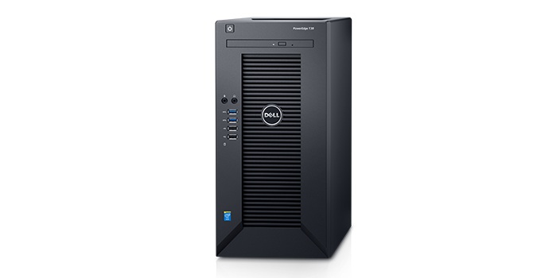

Figure 3.7 Dell Poweredge Server

The PowerEdge T30 server, by storing and sharing information, helps the network improve access to information, simplify processes and get more done in less time. It have large storage expansion for storing huge amount of patient medical report, web, etc. With it’s small design and low sound levels, T30 Allows to install virtually everywhere and provide a silent operation which is important to not disturbing the room arround the server room.

1. 1x Ubiquiti Unifi AC Lite Access Point



Figure 3.8 Ubiquiti Access Point

The AP have dual radio 802.11ac, good for crowded place like waiting room in the Hospitals, PoE Support

1. 20x HP AIO PC 20-C013D

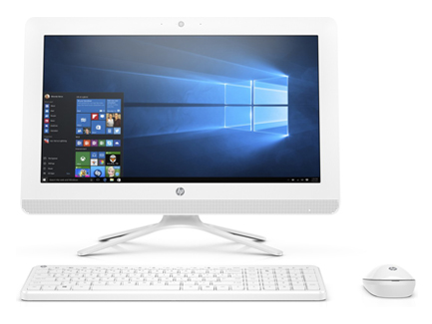

Figure 3.9 HP AIO PC

All in One pc that does Good Performance for its Price, making it suitable for Office usage and capable of handling basics task.

1. Epson Stylus Photo PX720WD

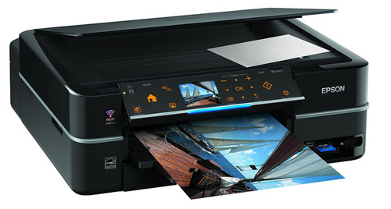

Figure 3.10 Epson Stylus LAN Printer

A General office printer with LAN port and a wireless printing system, good thing to have when the hospital’s wired network is down.

III.5 Software

In this specific Project, the Hospital’s network will require stability, reliability, and effectiveness. Based on that statement, the Network will use Windows 10 Desktop as the Host Operating System, and Ubuntu 16.0.1 Server for the Network’s Server’s Operating systems, below is the reason why the network should use those two mentioned Operating System.

1. **Windows 10**

Stability and overall performance of this OS is why many people choose this as their main desktop operating system. This OS is relatively new and got many support from it’s developer, Microsoft Corporation. Also the win 10 is already included on the AIO PC so the network did not cost additional expense for any closed-source host OS.

1. **Ubuntu 16.10 Server**

Ubuntu 16.10 Server is a stable server OS, the machine running this OS can run almost 24 hour a day, 7 day a week without restarting. This OS is an Open-source OS which means completely free to use. It got a lot of Software package to install, arround ~150.000 Packages is available through the Ubuntu apt.

1. **Office 365**

Office 365 is the brand name Microsoft uses for a group of software and services subscriptions, which together provide productivity software and related services to subscribers. For consumers, the service allows the use of Microsoft Office apps on Windows and macOS.

1. **E-Hospital Management software**

E-Hospital Management System is a patient centric & a generic application software, specifically meant for the hospitals in Government Sectors with its main objectives being to provide a mechanism to access the patient records and to have an efficient system to manage the Patient Information.

III.6 Network Media

The hospital will use both network media, Wired and Wireless. The Wired network is required for connecting a room with another. The Wireless network is required for the Patient and other visitor internet access.

III.7 Cost

Below is the table of how much the network costs, according to the drawbacks of Hybrid Topology, the network engineer must press the budget as small as possible, so that the money can be used for setting up additional networks and/or for overhead (unexpected) outcome.

|  |  |  |  |  |
| --- | --- | --- | --- | --- |
| **No**. | **Item Name** | **Qty.** | **Price (IDR)** | **Total Price** |
| 1. | MikrotikRB915G Router | 2 | 1.000.000 | 2.000.000 |
| 2. | Belden CAT5E UTP | 5 | 1.300.000 | 6.500.000 |
| 3. | Cisco SG200-08 Switch | 6 | 1.500.000 | 9.000.000 |
| 4. | Cisco SG200-18 Switch | 1 | 4.000.000 | 4.000.000 |
| 5. | VoIP Phone Yealink | 5 | 1.000.000 | 5.000.000 |
| 6. | RJ-45 Connector | 5 | 100.000 | 500.000 |
| 7. | Dell T30 Server | 1 | 11.000.000 | 11.000.000 |
| 8. | Ubiquiti Unifi Lite AP | 1 | 1.200.000 | 1.200.000 |
| 9. | HP AIO PC 20-C013D  (Windows 10 OEM Home Edition Included) | 20 | 4.500.000 | 90.000.000 |
| 10. | Epson Stylus PX720WD | 5 | 2.000.000 | 10.000.000 |
| 11. | Wallmount Network Box | 1 | 2.000.000 | 2.000.000 |
| 12. | Miscellaneous (Cable Ties, shield, etc.) | n/a | 1.500.000 | 1.500.000 |
| 13. | Monthly 365 Office License | 20 | 90.000 | 1.800.000 |
| 14. | E-Hospital Management Software | 1 | 15.000.000 | 15.000.000 |
|  |  |  | Total : | 159.500.000 |

Tables 3.3 Network Costs

CHAPTER IV. CONCLUSION AND SUGGESTION

IV.1 Conclusion

Network is a Collection of devices that connected to one another, thus creating a integrated connection, in order to create a network, first thing is to overlook a Topology and the Architecture and decide the media and device used within the Network.

In the Hospital, a Network Engineer must think smartly how to build a stable, secure network. Hybrid Topology provide flexible connection allowing the Engineer to add more devices aswell as forgiving network failure without disturbing the whole network.

The Network Engineer must choose the devices of the network wisely as the Hospital’s gave zero tolerance for failure. As for the Network media, hospital needs a stable network and maximize visitor experience, that’s why hospital’s need both wired and wireless connection.

Hospital needs a management software to ease up the employees. As for the network cost, the Network Engineer must press the budget as small as possible, choosing the inexpensive but powerful devices is a must.

IV.2 Suggestion

Even with the Complexity of the Network setup, it can not guaranteed 100% safety, to anticipate it is recommended for the Administrators to perform a weekly data backup, to anticipate the Network Failure caused by user error or a Natural Disaster.

BIBLIOGRAPHY

Reference From Site :

1. <http://wikieducator.org/Computer_Basics/Hardware/Types_of_hardware> [22/09/2017]
2. <https://www.cisco.com/c/dam/en/us/products/collateral/switches/small-business-100-series-unmanaged-switches/brochure_c02-642208.pdf> [22/09/2017]
3. https://www.cisco.com/c/en/us/support/switches/sg200-18-18-port-gigabit-smart-switch/model.html [22/09/2017]
4. <http://www.dell.com/in/business/p/poweredge-t30/pd> [22/09/2017]
5. <https://www.computerhope.com/jargon.htm> [25/09/2017]
6. <https://www.computerhope.com/jargon.htm> [25/09/2017]
7. <https://en.wikipedia.org/wiki/IP_address> [26/09/2017]
8. <https://en.wikipedia.org/wiki/Wireless_network> [26/09/2017]
9. <https://www.lifewire.com/servers-in-computer-networking-817380> [26/09/2017]
10. <https://www.nfon.com/en_de/cloud-telephone-system/resources/glossary/ip-phone>/ [26/09/2017]
11. <https://support.hp.com/id-en/document/c05150882> [26/09/2017]
12. <http://wikieducator.org/Computer_Basics/Hardware/Types_of_hardware> [28/09/2017]